EXPERIMENT NO - 6
AIM: CPU-OS Simulator
TOOLS/SOFTWARES REQUIRED: Windows OS
THEORY:
Process Scheduling Algorithms: Process scheduling algorithms determine the order in which processes use the CPU, aiming to maximize CPU utilization, throughput, and efficiency while minimizing waiting and response times. Its types are:
- First Come First Serve
- Shortest Job First (Pre-emptive or Non-pre-emptive)
- Round Robin
- Priority (Pre-emptive or Non-pre-emptive)
Threads: A thread, often called a lightweight process, is the smallest unit of execution within an operating system process. Threads enable concurrency, allowing multiple tasks—like loading, processing, and handling user input—to run simultaneously, improving application performance, responsiveness, and resource utilization by sharing memory and resources with other threads.
Deadlock: A deadlock in an operating system is a state where a group of processes are permanently blocked because each holds a resource while waiting for another resource held by another process in the group. It causes system inactivity, commonly caused by competition for limited resources like CPU, memory, or I/O devices.
Scheduling Algorithms Output:
FCFS:
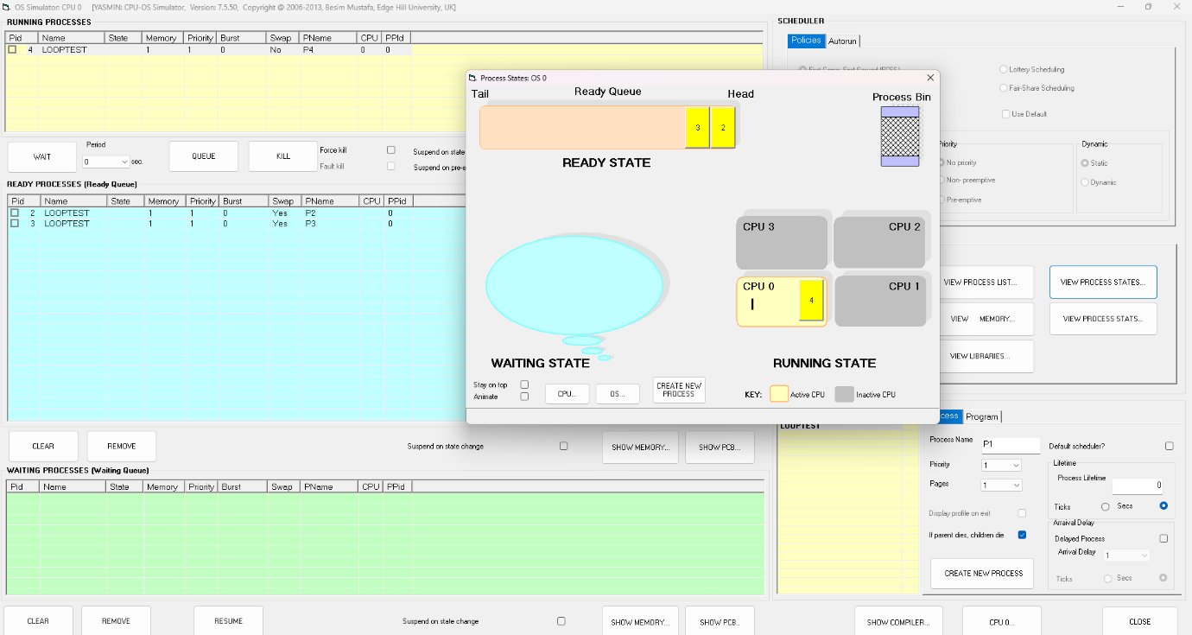
SJF (NP):
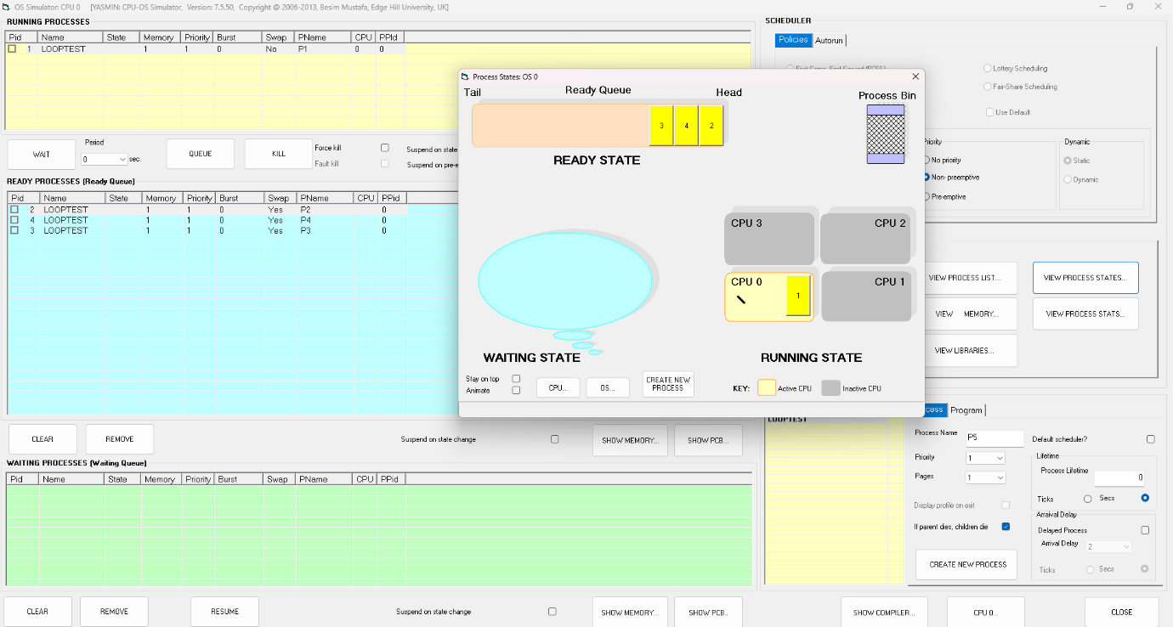
SJF (P):
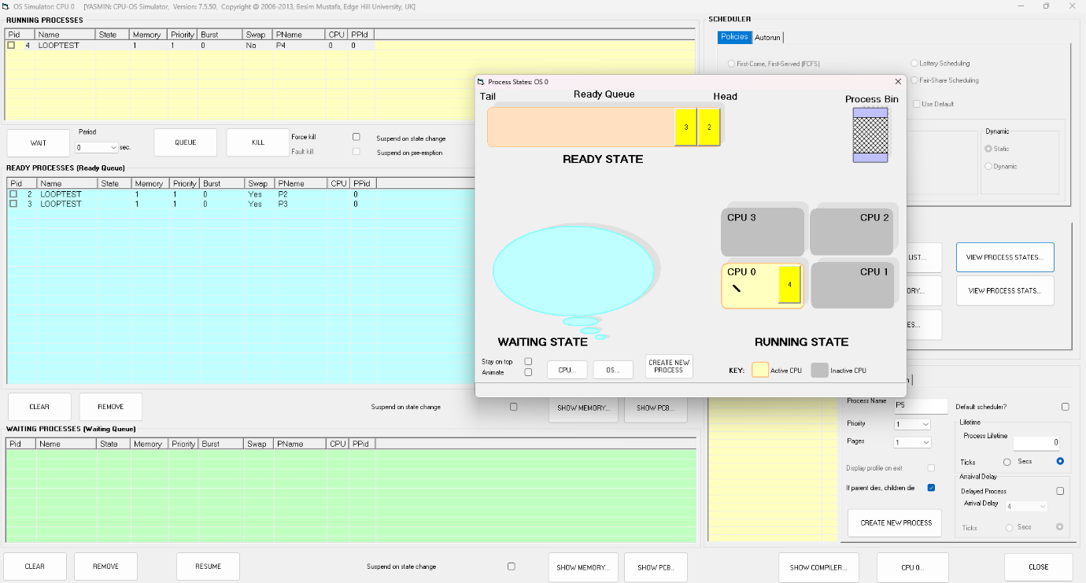
RR (NP):
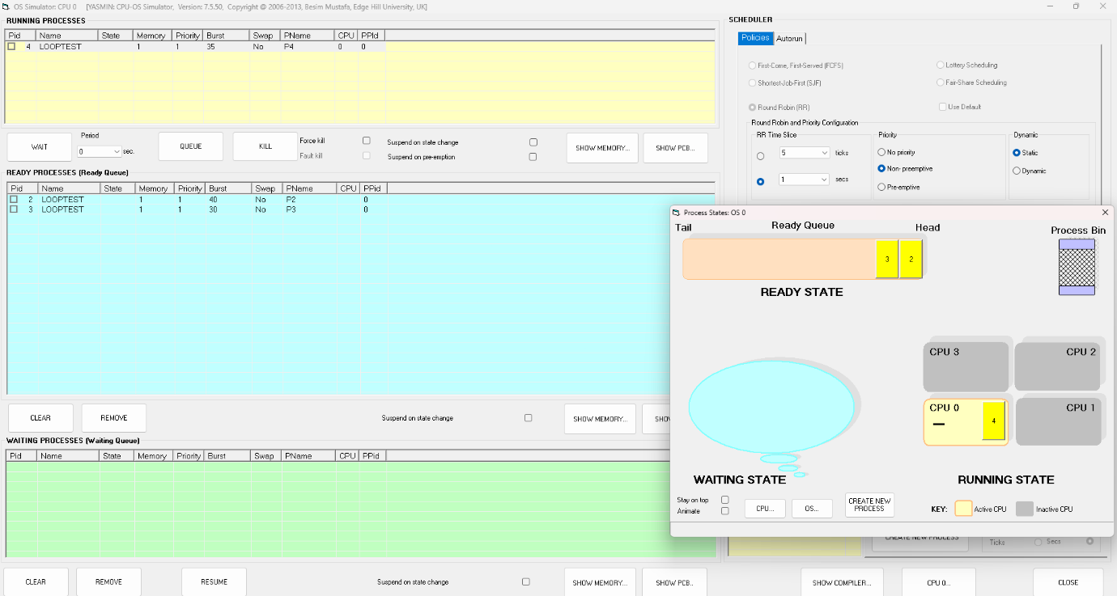
RR (P):
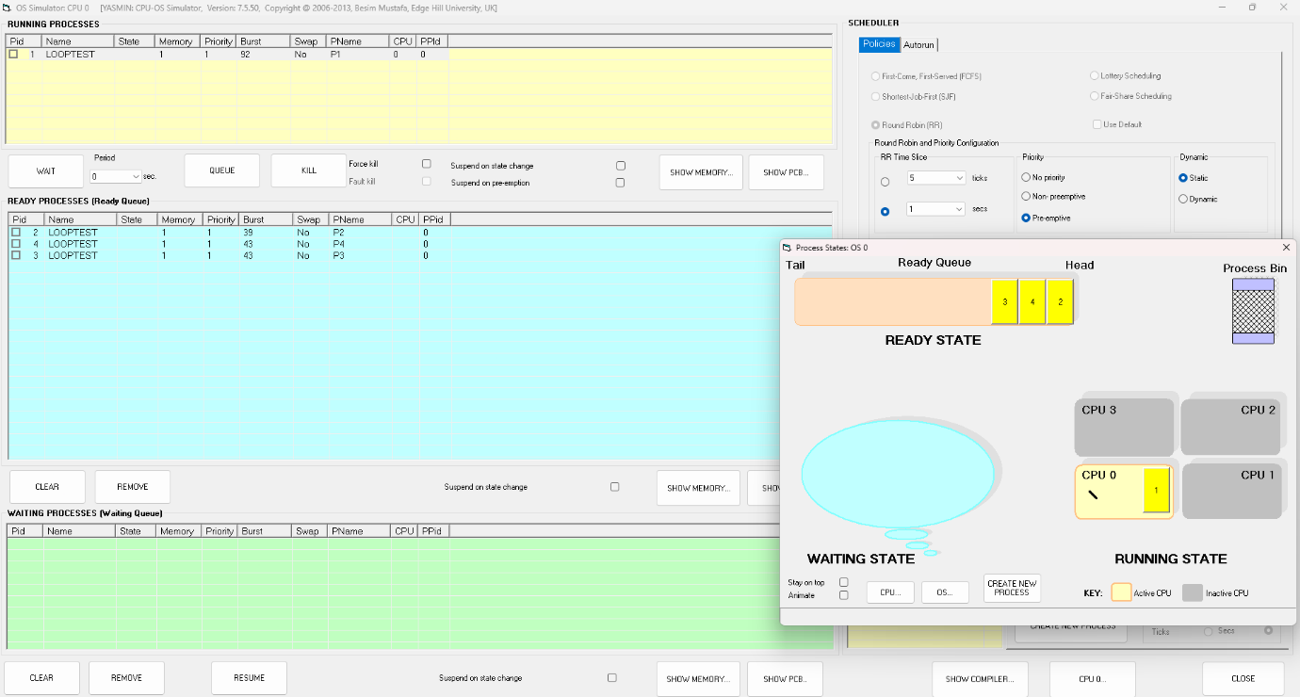
Thread Creation and Synchronization:
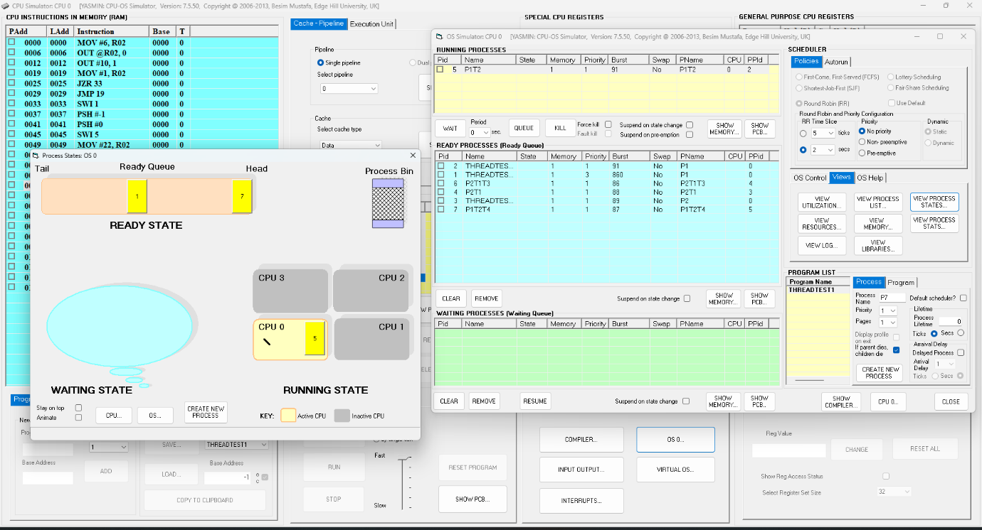
Deadlock prevention and avoidance:
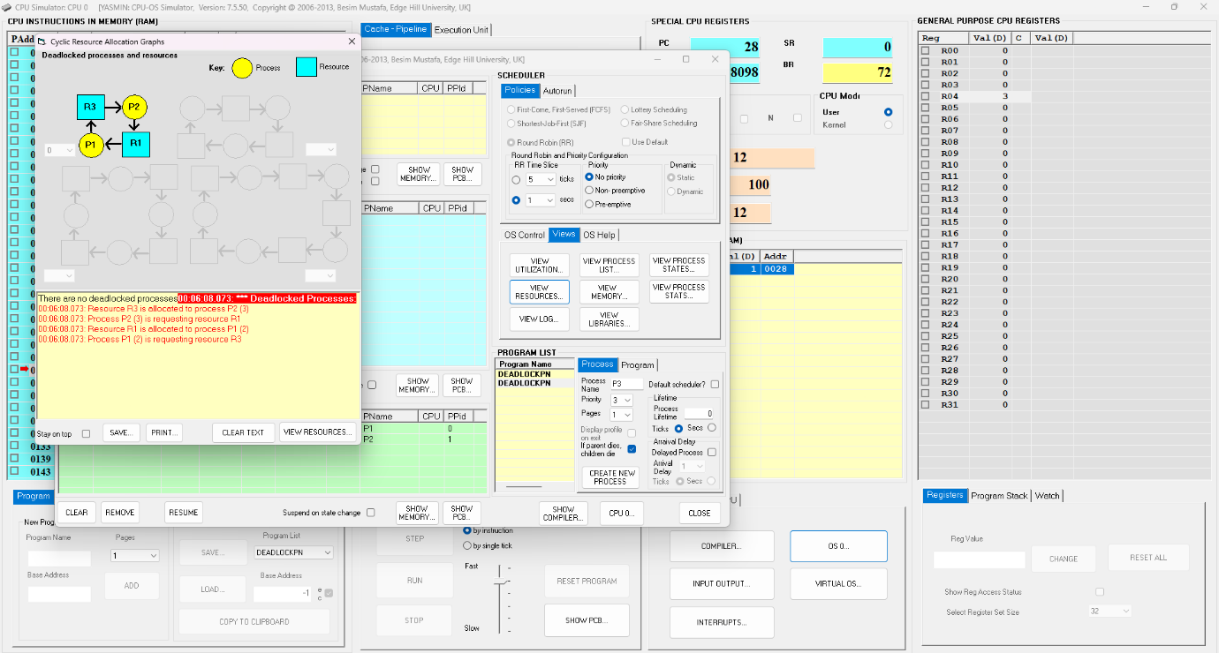
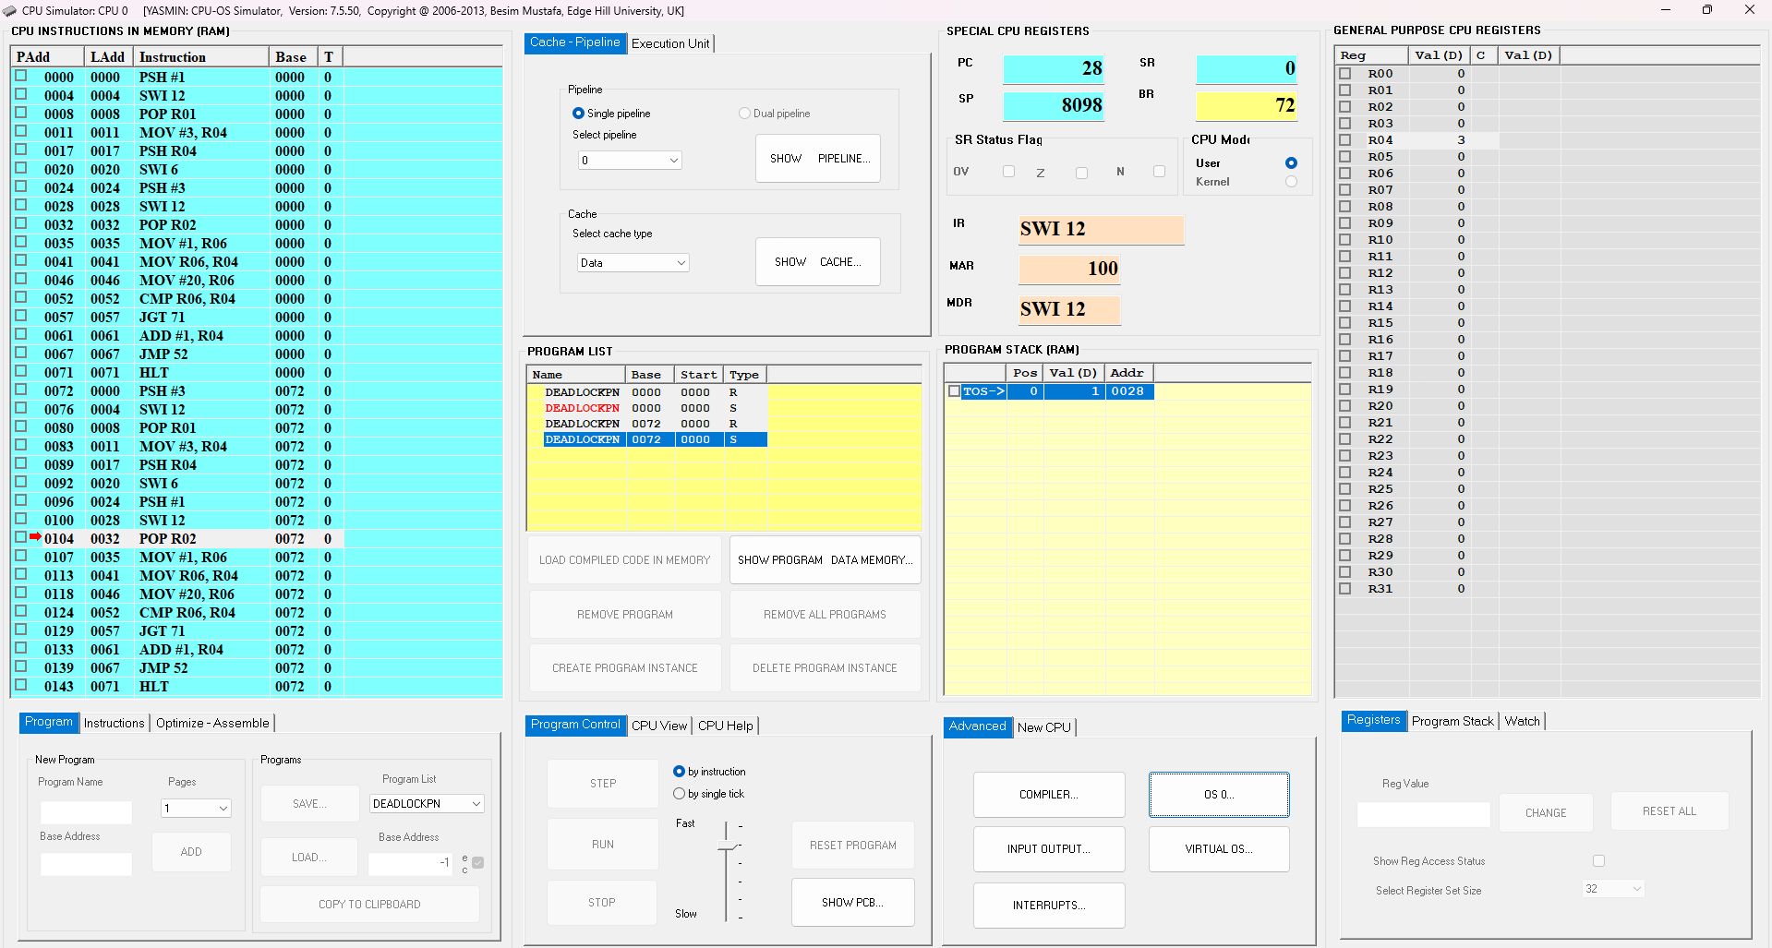

CONCLUSION: Hence, we have used the CPU-OS Simulator in Windows OS to look at various functions of the OS and how they work like the different scheduling algorithms, creation of threads and their synchronization, and finally about deadlocks, how to prevent and avoid them.

